**EXCEL 101: HOW TO SET UP CASH BOOK SYSTEM**

Microsoft Excel can be used to organize data and perform financial analysis. It is used across all business functions and at companies from small to large. It is also used for Accounting related stuffs and in this article, we are going to design a Cash Book in Microsoft Excel. This Cash Book shall be used to keep the Cash Account, Bank Account, and Discount Accounts.

We will apply different formulas and steps will be provided for better understanding. We will use the **Formulas Ribbon** to create names, the **Data ribbon** to create drop down list, we will use **IF statement** to specify conditions, and the **SUM function** as you cannot do away with it in Accounting.

Okay, let us begin. To create the Cash Book, you will need three sheets, so create Sheet1, Sheet2, and Sheet3. Rename Sheet1 as ‘File’ to keep your chart of Accounts, Sheet2 as ‘Receipt’, and Sheet3 as ‘Payment’ as show below:

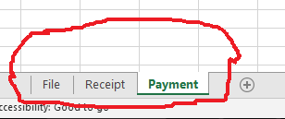

Cash Books usually has a column called **Particulars** which is used to store information about customers, suppliers, etc. We will start by defining the list of items that will go into the Particulars column in the **‘File’** sheet. Below is an illustration of the File sheet and what will go into it.

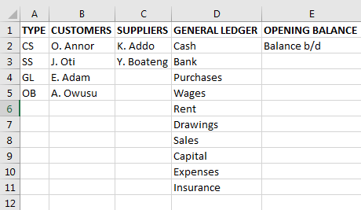

Now let us talk about Excel tables, they can be very useful and make your spreadsheet much easier to use, share, and update. Now we will convert the list above to a table. Click anywhere inside the data and click the Insert tab from the Ribbon as shown below:

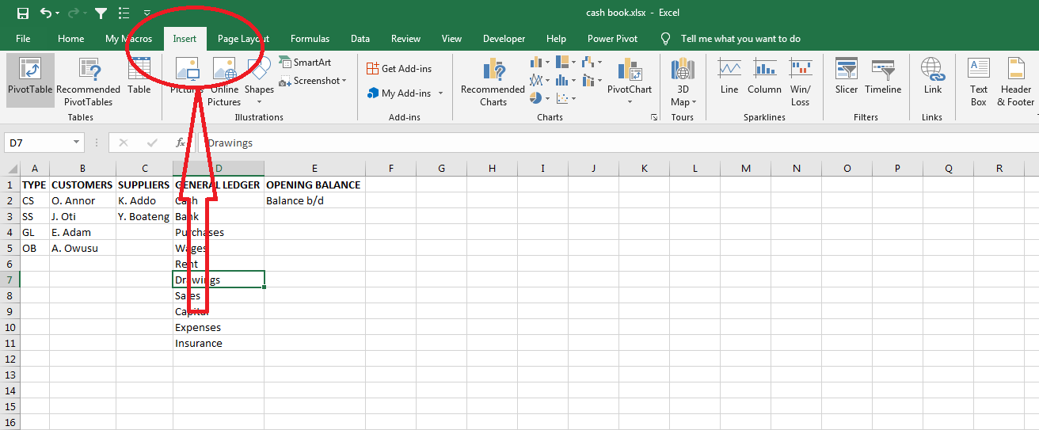

Now click on the Table icon as shown below:

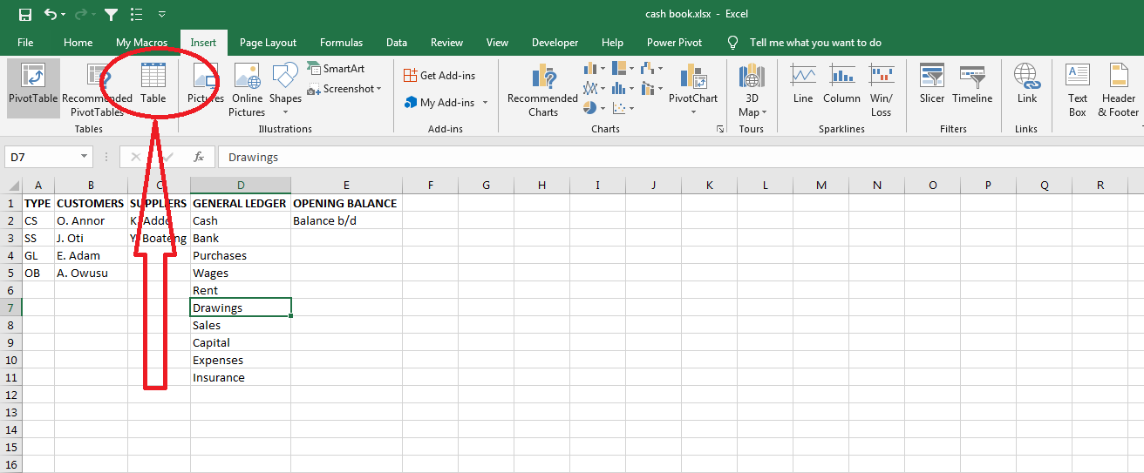

You will get a dialog box like this:

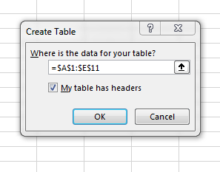

Select ‘My table has headers’ checkbox and click ok. You will get a table that look like this:

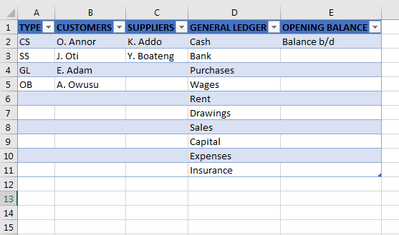

Now we will rename our table for it to be easier for us to use. To rename the table, click on the ‘Design’ tab in the ribbon as shown below:

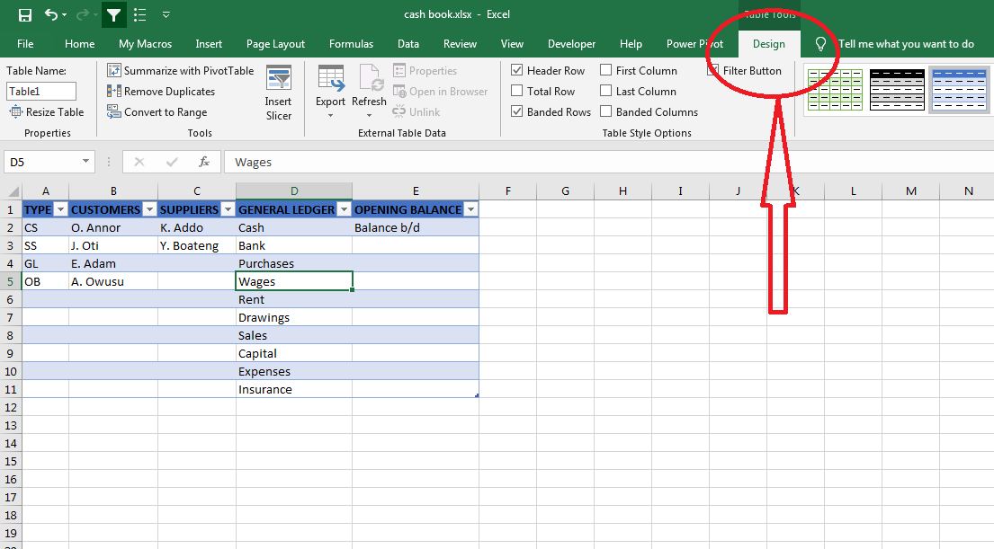

Now click inside the textbox under ‘Table Name’ as shown below and rename the table from ‘Table1’ to ‘accounts’.

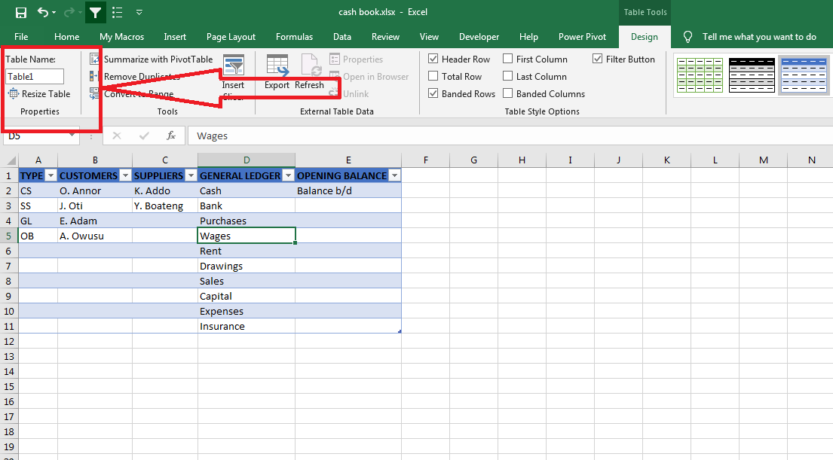

We have finished with the ‘File’ sheet. Let us move to the ‘Receipt’ sheet. Below is an illustration of the ‘Receipt’ sheet and what will go into it:

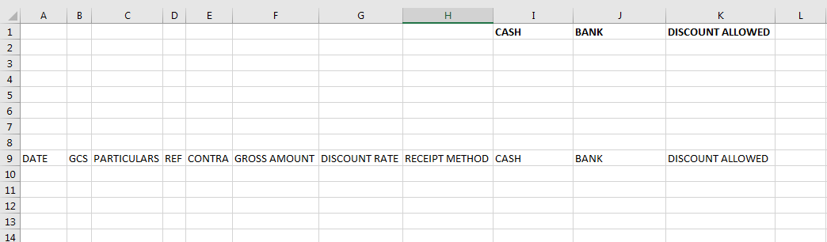

Now highlight from row ‘A9’ to ‘K10’ and click the ‘Insert’ tab in the ribbon and click on the ‘Table’ icon to insert a table. Now select ‘My table has headers’ checkbox from the dialog box that will appear and click ok. You will get a table that look like this:

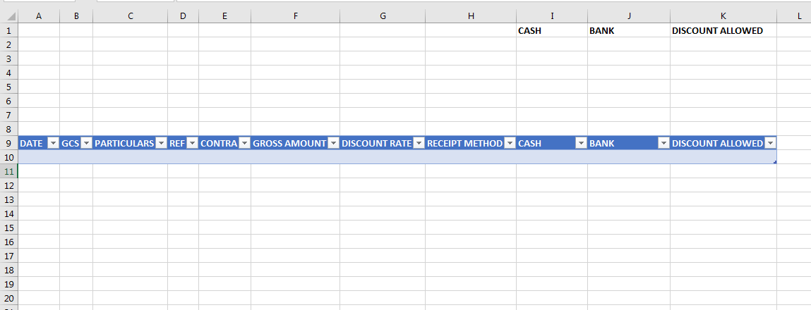

Rename the table name to ‘receipts’.

Note that throughout the work, stick to only two rows (that is row 9 and row 10). Do not add additional row until after all formulas have been entered. The table will automatically be extended to next row(s) when you start recording entries.

We will start by creating a drop-down list for the type of account under the column heading ‘GCS’.

Now before we begin to dive into what goes on the receipt, let us create names for the different type of accounts we have in the ‘File’ sheet. This will allow to use conditional drop-down validation list. We will create five (5) names.

‘TYPE’ corresponds to the Type column in the accounts table

‘CS corresponds to the Customers column in the accounts table

‘SS corresponds to the Suppliers column in the accounts table

‘GL corresponds to the General Ledger column in the accounts table

‘OB corresponds to the Opening Balance column in the accounts table

The table below illustrates what will go into the ‘Name’ textbox and ‘Refers to’ textbox form the name dialog box:

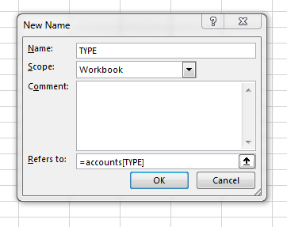

|  |  |
| --- | --- |
| Name | Refers to |
| TYPE | =(accounts[TYPE]) |
| CS | =(accounts[CUSTOMERS]) |
| SS | =(accounts[SUPPLIERS]) |
| GL | =(accounts[GENERAL LEDGER]) |
| OB | =(accounts[OPENING BALANCE]) |

From the Formulas Ribbon, Click on Name Manager.

Click on New button to create the names.

Select cell ‘B10’ under ‘GCS’ column.

From the Data Ribbon, Click on ‘**Data Validation’**.

From the Settings Tab, select ‘List’ from the ‘Allow’ dropdown. Maintain ‘**Ignore Blank’** and **‘In-Cell dropdown’** options as Ticked.

From the Source Box, enter =TYPE and click on OK.

Let’s create an automatic dropdown list under particulars which will depend on the selection under column heading GCS. This is to ensure that when you want to process an entry (e.g.) for a customer, you will have to select CS under the column headed GC before the list of customers could be found under the particulars column to be able to select the customer in question. The steps below would guide you to create such a list:

Below the Particulars Side of the ‘Receipt’ sheet, select the first empty cell.

From the Data Ribbon, Click on **‘Data Validation’**.

From the Settings Tab, select ‘List’ from the ‘Allow’ dropdown. Maintain ‘**Ignore Blank’** and **‘In-Cell dropdown’** options as Ticked.

From the Source Box, enter=Indirect(B10). Note that B10 is not a constant cell. ‘B’ refers to column where we have GCS as a heading and the ‘10’ refers to Row you are working on. If you are creating the list in say row 8 and GCS is in Column B, the function would now be =Indirect(B8) instead of the above. Always make sure to follow this rule as in excel, the principle of GIGO also applies.

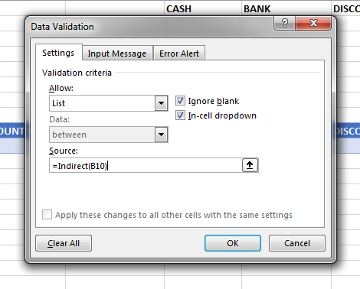

**Contra Entry:** when a transaction needs to be recorded into the cash and the bank accounts simultaneously, such a transaction is known as contra entry. For example, ‘cash paid into bank’ and cash ‘withdrew from bank for business use’. For such transactions, we usually write “C” under the folio column in the manual cashbook system. In this system, we need a formula to automate such transactions. The formula below is used to automate contra entries:



In this Cash Book system, all amount received are recorded at the Gross Amount Column. To be able to allocate such an amount to either the **Cash** or the **Bank** column, a receipt method must be selected.

**Discount Rate:** format the column to contain figures in percentage. In this column, any discount allowed to a customer is entered and the system automatically computes the discount amount and based on a formula, the amount is recorded into the **“Discount Allowed”** Column.

**Receipt Method:** create a receipt method as either **Cash** or the **Cheque.** In the **‘Receipt Method’** column, go to the ‘Data Ribbon’ and click on Data Validation. Then select ‘Allow List’. In the source box, type **Cash,Cheque** and click OK.

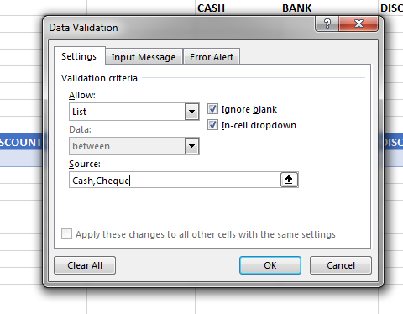

In the Bank Column, enter the following formula:

**=IF(LOWER(C10)="cash",F10,IF(LOWER(H10)="cheque",F10-K10,""))**

The allocation of the amount to Bank column depends on two conditions:

1. When the transaction is a contra entry: in this case the particulars column should contain **Cash.** For contra entry, the whole amount (Gross Amount or ‘F10’ as shown above) received/paid must appear at the Bank Column. This is shown in the formula above as **=IF(LOWER(C10)=”cash”,F10**
2. Where the transaction is not a contra entry: with this, the user of the systems should ensure that the receipt or the payment is in Cheque. That is, if the receipt/payment method (H10) is Cheque then the Gross Amount (F10) less any available discount (K10). This is shown in the second part of the above formula as **IF(LOWER(H10)=”cheque”,F10-K10,””))**

Note that discount does not affect the contra entry. Also from the second situation, where there is no discount, then K10 would be zero and zero from the gross amount is the same gross amount.

In the Cash Column, enter the following formula:

**=IF(LOWER(C10)="bank",F10,IF(LOWER(H10)="cash",F10-K10,""))**

The allocation of the amount to Cash Column also depends on the same two conditions:

1. When the transaction is a contra entry: in this case the particulars column should contain **Bank.** For a contra entry, the whole amount (Gross Amount or F10 as shown above) received/paid must appear at the Bank Column. This is shown in the formula above as **=IF(LOWER(C10)="bank",F10**
2. Where the transaction is not a contra entry: with this, the user of the system should ensure that the receipt or the payment is in **Cash.** That is, if the receipt/payment method (H10) is **Cash** then the Gross Amount (F10) less any available discount (K10). This is shown in the second part of the above formula as **IF(LOWER(H10)="cash",F10-K10,""))**

**Discount Allowed:** in this column generate a formula to compute the available discount on the amount received or paid. This amount is then deducted from the Gross Amount. This is calculated using this formula: **=F10*G10**

We are done with the ‘Receipt’ sheet, let us move to the ‘Payment’ sheet. Select and copy the entire ‘Receipt’ sheet and past onto the ‘Payment’ sheet. At this point, you are only to change ‘Receipt Method’ to ‘Payment Method’ and ‘Discount Allowed’ to ‘Discount Received’.

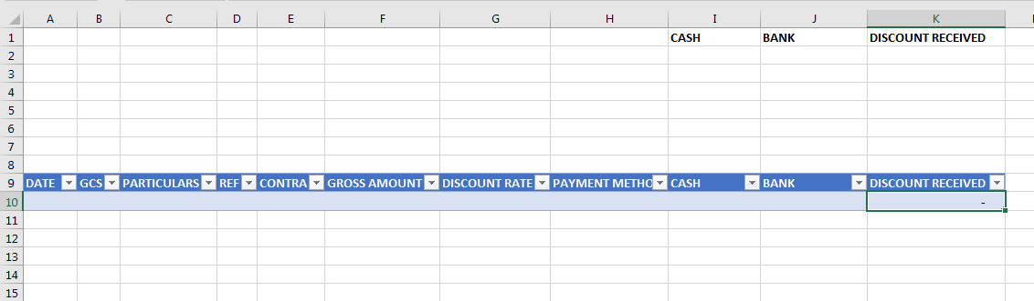

Rename the table name to ‘payment’ on the ‘Payment’ sheet.

**Let us calculate the Closing Balances:**

**Cash Column:** the formula below is used to calculate the closing balance for cash.

**=SUM(receipts[CASH]) - SUM(payment[CASH]).** The first part of the sum function i.e. **=SUM(receipts[CASH])** is the sum of the receipt side. After this, the minus (-) sign, followed by **SUM(payment[CASH]).**

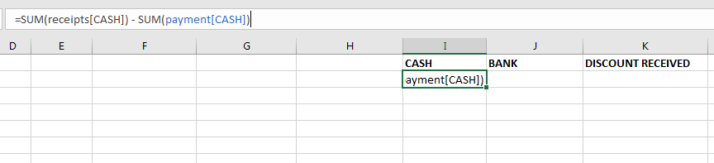

**Bank Column:** the formula to perform this calculation is as follows:

**=SUM(receipts[BANK]) - SUM(payment[BANK])**.

**Discount:** this is calculated by summing up all values under Discount column. Unlike the Cash and Bank, there will be no deduction since the receipt column discount is different from the payment column discount.

**=SUM(receipts[DISCOUNT ALLOWED])** for Discount Allowed on the ‘Receipt’ sheet.

**=SUM(payment[DISCOUNT RECEIVED])** for Discount Received on the ‘Payment’ sheet.

Our Cash Book System is now complete for use.

Now enter the following data into your Cash Book.

**January 2012**

1st Balance: Cash 650,000, Bank 250,000 (Cr)

2nd Cash sales paid directly into bank 800,000

4th Introduced 600,000 cash into the business

6th Paid K. Addo 30,000 by cheque

7th A. Owusu paid us by cheque 150,000

9th Cash drawings 650,000

11th The following people paid us their accounts by cheque, less 10% discount: O. Annor 600,000; J. Oti 500,000; E. Adam 450,000

14th Wages paid in cash 80,000

16th Rent paid by cash 50,000

17th Motor expenses paid in cash 75,000

20th Goods bought and paid in cash 440,000

22nd Paid insurance 74,000

28th Cash sales paid directly into bank 80,000

30th A. Owusu paid us his account 500,000 less 5% discount

31st Withdrew 200,000 from bank for business use

31st We paid the following their accounts by cheque less 10% discount: Y. Boateng 600,000; K. Oppong 800,000.

You can download the excel sheet I used from this link <https://github.com/danielafriyie/ds_projects/tree/main/excel_projects/cash%20book%20system>.

I have also entered the data above into it. You can compare it with yours for any discrepancies.